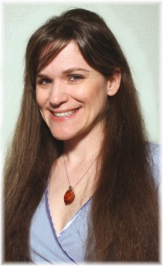 Sherry Pence
Sherry Pence has been tatting since 1987. Being a professional potter, she combined her love of pottery and tatting by creating one-of-a-kind ceramic tatting shuttles. After discovering the online world of tatting, she found inspiration to follow other tatting pursuits such as blogging, designing, teaching, and writing. She received her “Master Tatter” certificate in 2009.
She also hand dyes the highest quality threads and silks, makes precious metal shuttles, and unique hook pens, as well as many other tatting pursuits.

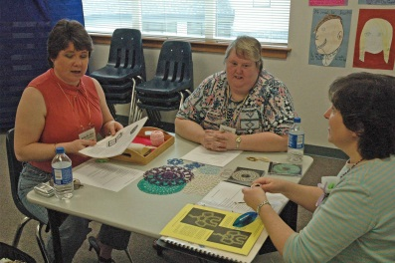
Cheryl Birch (center)
I learned to tat in 1980 with a shuttle, did very little until I found needle tatting from Barb Foster at around 1994. Picked up needle tatting and at some point about 1998 I found The Shuttlebirds Workshop, and was determined to needle tat my way through the first workshop, but got a renewed gumption at shuttle tatting while there. I started teaching needle tatting at Ben Franklin and another craft store. I finally mastered shuttle tatting and have not gone back to needle tatting since then. I have left off teaching at the craft stores and started teaching at two of the senior centers here in town because there was an amazingly long periods at a time when no one signed up. And now I have dropped down to only one Senior Center and have a couple of students who have faithfully returned term after term for about 6 years now. I have also taught at the workshop in the past.

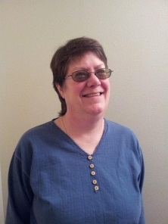 Lauren Snyder
I learned to tat at an EAA Fly-In 20 years ago. Tatting has been an all- consuming passion ever since. I like to keep things simple in tatting, even going so far as to use thread ends as a design element.

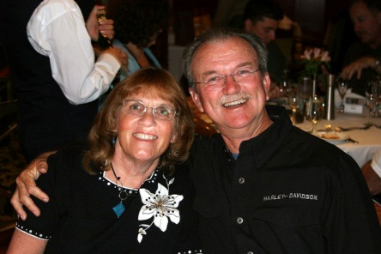
Hello, my name is Judy Hoag, and I live with my hubby of 38 years in Acampo, CA. I am 63, and we have recently been blessed with our first grandchild! Like most tatters, I love "all" types of needlework. My 45-year working career has deprived me of some precious tatting time! However, a few years ago I learned the Daisy Picot, and have devoted my extra time to designing Daisy patterns. I am honored to share these ideas with the Shuttlebirds!

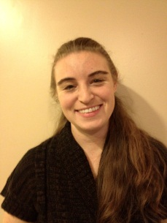
Jessica Spaulding remembers being fascinated as a child by her grandmother’s tatting. She finally decided to take the plunge and learn while in college and has been obsessed with tatting ever since. She lives in Seattle, Washington where she is studying to be a CPA and blogs about tatting at Snapdragonlace.com. Her tatting patterns are available for sale on Etsy and Craftsy. This will be her 4th year teaching at Shuttlebirds.

 Patty Markley
I live in Medical Lake WA and have been active with the Shuttlebirds tatting guild for a number of years. I am currently the vice president and am a past president. I was taught to tat by my grandmother as a child but did not remember how to do it after I grew up. I met a lady at my church that was tatting one day and she showed me how again. That was about 17 years ago and I have been tatting ever since. She also introduced me to the Shuttlebirds tatting workshop and I have been coming to it every year since then. I also enjoy all types of needlework, sewing, and quilting. I am married and have two grown daughters neither one does any type of handwork.

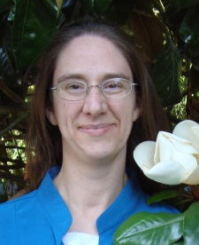 Sarah Nielson
Sarah Nielson learned to tat when she had the pleasure of taking a class from Camelia Crapo Scheidegger in 1997, and has been happily making lace ever since. She currently lives in Seattle with an uncertain number of shuttles, not quite enough books, and an embarrassing number of UFOs (UnFinished Objects).

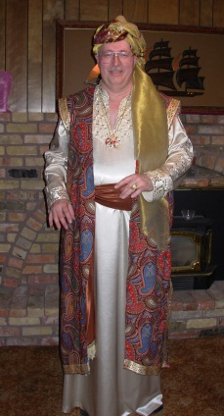 Dale Pomeroy
Tatting is a branch of lace made by a lark’s spur/lark’s head knot on a running line using the hands and a shuttle, needle or hook. Through an extensive self-study program, I have been actively involved with this form of lace-making since I was twelve. I have been teaching tatting since 1981.
Venessa Godfrey
I started tatting in 1980 when we were stationed at Keesler AFB in Biloxi, MS. Since then I have enjoyed teaching and sharing tatting in many parts of the country.

Patti Duff
I learned to tat in the fall of 1969 from my maternal grandmother. I remember sitting next to her rocking chair fascinated by the clicking sound as her shuttle flew back and forth. I taught my first student within a year (and she is still tatting). After attending the IOLI convention in 1995, I started the Shuttlebirds Tatting Guild in 1996 and the workshop in 1997. Currently, I am teaching beginning classes three weeks a month.

Lois Bresnahan
I've been tatting for almost 47 years, I'm a member of the guild, & have been known to teach tatting to anyone who wants to learn on public transportation. (Have shuttle, Will teach)

Wendy Griffin
I started tatting in 2002 to keep my hands and mind busy while spending long times in the hospital. My mom tatted, so I knew what it looked like and how portable it was, but I learned from the same book she did since I'm a lefty and she is not. I started by making bookmarks for all my nurses and staff and graduated to other things. Bookmarks are still my favorites. I love teaching other people to needle tat and watching the light bulb go on as they get the techniques. I love tatting with non-traditional threads and materials and learning new things. I have become a paperclipaholic and will be starting a support group soon for others who too have become addicted (or will become addicted). This is my third year teaching at the Shuttlebird's Workshop. My day job is with the American Red Cross.

No bio provided
Mary McCarthy

Pat Stevens

